

API Client Store Guide

Luke Solomon

12/22/2017

|  |
| --- |
| Version 2.0 | Sarah Knowles |

API Client Store Guide

Contents

Overview 2

Logging into the API Store 2

Logging out of the API Store 2

Viewing API Documentation 2

API Console (Swagger UI) 3

Documentation (Supplemental) 5

Trying out APIs 5

API Console (Try it Out) 5

Subscribing to New APIs 7

Regenerating Access Tokens 9

# Overview

This document contains instructions on how to use TicketNetwork’s API store to view API documentation and use a DefaultApplication to try out APIs through the API Console in Sandbox.

# Logging into the API Store

Navigate to <https://console.tn-apis.com/store> and log in to your account using the “Sign In” link located in the top menu to the far right. If you are already logged in your username will appear here instead of the “Sign In” link.



|  |  |
| --- | --- |
| Your Store Login | |
| Username | LukeSolomon-store |
| Password | 8Hs^o7fDp#)v |

You will not be able to view any APIs or their documentation unless you are logged into your account.

# Logging out of the API Store

After a period of time (about 20 minutes) you will automatically be logged out of the API store, but if you wish to log out before then you can do so by clicking on your username in the top menu on the far right. A popover will appear with a link to “Sign Out”, which can be used to end your store session.



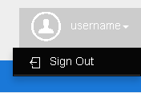

# Viewing API Documentation

All API documentation is available directly in the store. This documentation can be used to gain an understanding of what resources each API offers and start planning your API integration. Supplemental materials, such as a Client Integration Guide, will also be provided during the start of the integration process.

To view the documentation for an API, navigate to the API’s page in the store via the sidebar.

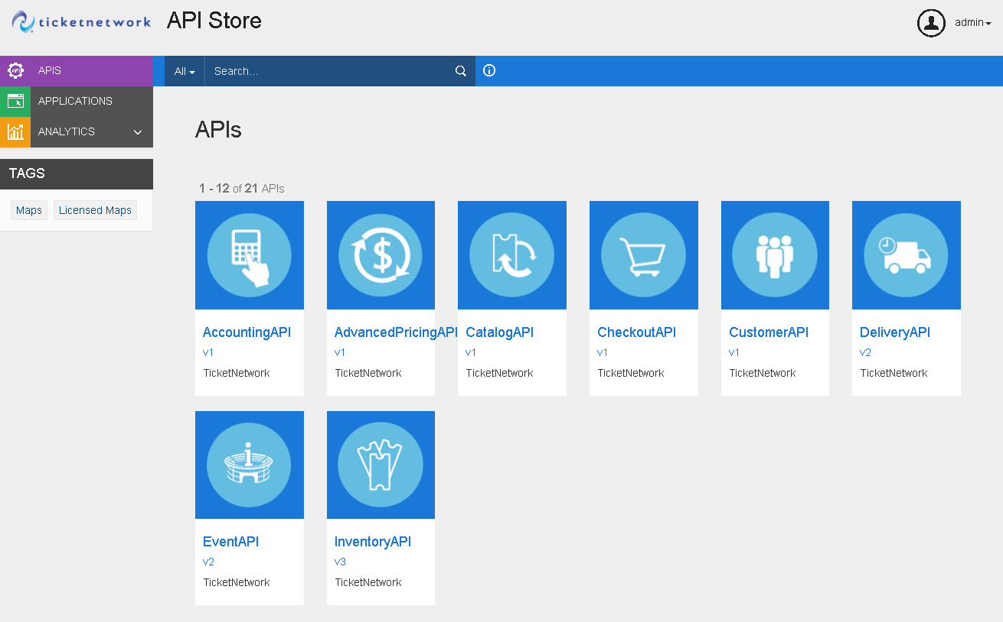

## API Console (Swagger UI)

The “API Console” tab contains Swagger UI documentation that defines the structure of the API and its responses.

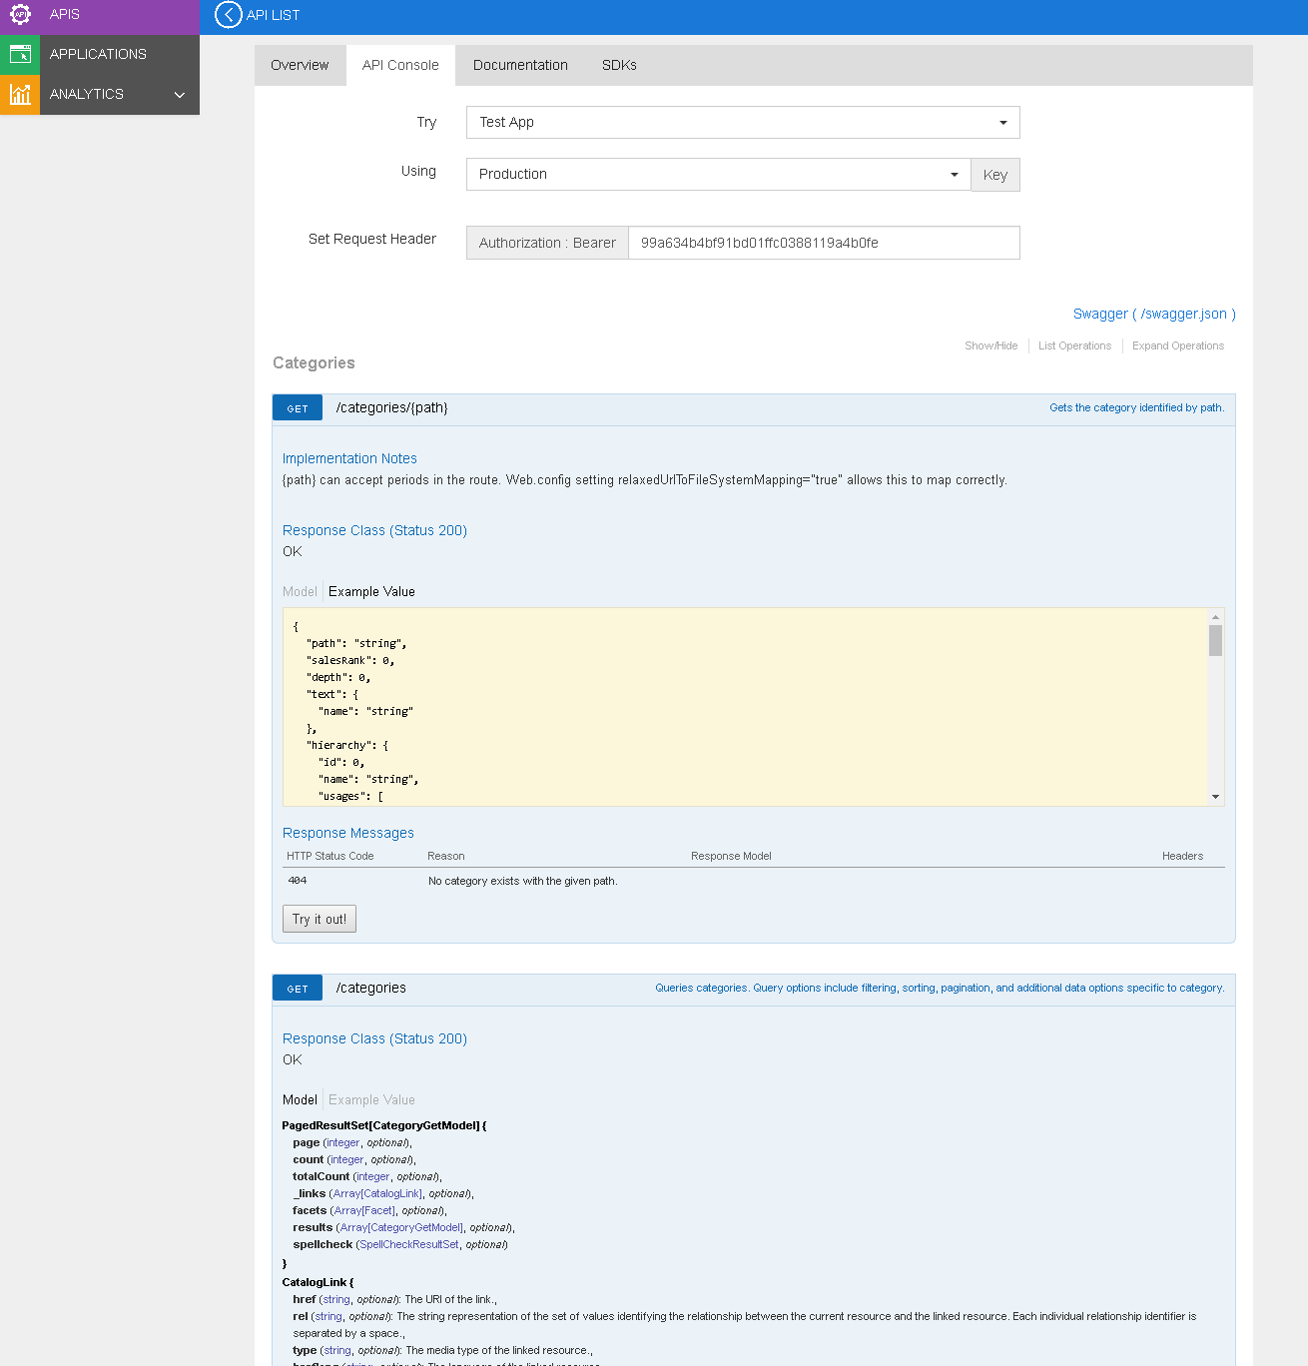

## Documentation (Supplemental)

The “Documentation” tab contains additional information that is useful for integrating with the API, ranging from workflows and samples, to test cases and details on expected URL parameter syntax.

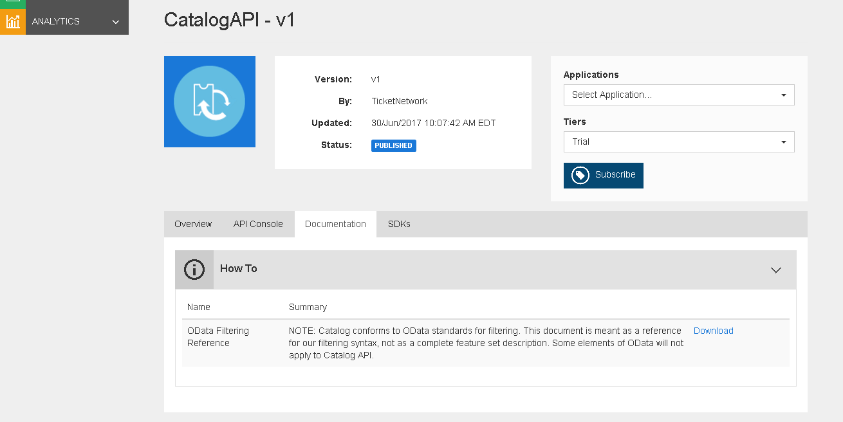

# Trying out APIs

## API Console (Try it Out)

You can try out calls to APIs you are subscribed to within the store by navigating to the API’s page, then going to the “API Console” tab.

1. Choose “DefaultApplication” and “Sandbox” in the Try [Application] Using [Environment] Key select dropdowns.
2. Expand the resource that you want to try by clicking on the resource path.

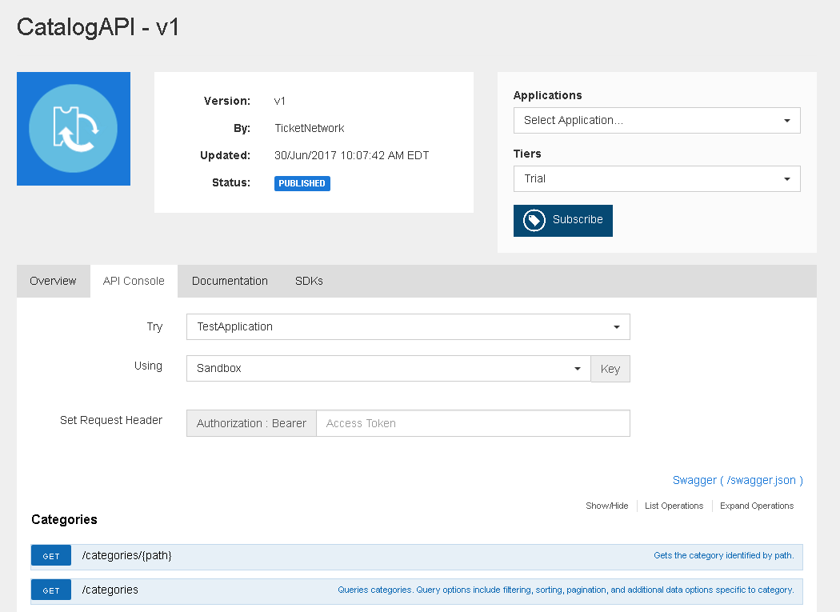

1. Fill out the request parameters.
2. Click the “Try it out!” button.

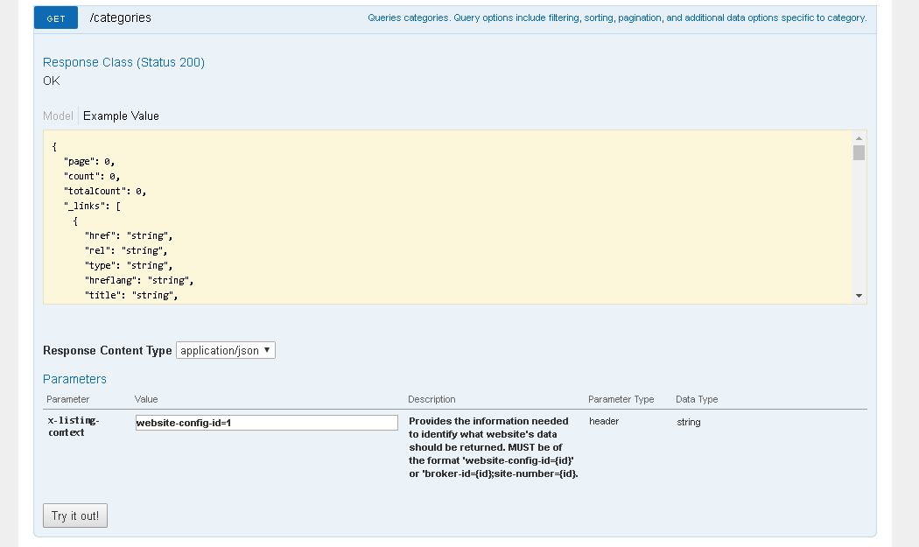

## Subscribing to New APIs

The TicketNetwork APIs are hosted in two environments: Sandbox and Production. The Sandbox environment is built for integration and testing, and the Production environment is for live traffic.

A DefaultApplication has been created for you which you can use to try out our APIs in the Sandbox environment. A subscription to Catalog API has already been added for your DefaultApplication, and **requests against resources associated with website 237 (ticketliquidator.com) are allowed**. If you want to try out any of the other APIs available to you, you can do so by subscribing to those APIs as well.

1. Navigate to the API you want to subscribe to via the sidebar or the APIs link in the top menu.
2. Select DefaultApplication in the “Applications” dropdown near the top-right of the page content. If your DefaultApplication is already subscribed to this API it will not show up in the list.
3. Choose the Trial subscription tier in the “Tier” dropdown. The tier controls the throttling applied for this subscription.
4. Click the “Subscribe” button.

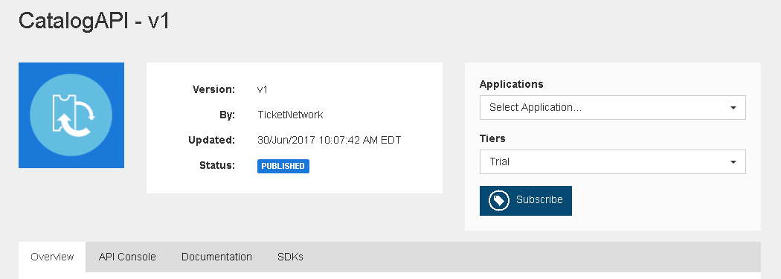

After subscribing to an API it will only be available to you in the Sandbox environment. You can view and manage your current subscriptions by clicking on “Applications” in the sidebar, choosing the application you want to manage, and going to the “Subscriptions” tab.

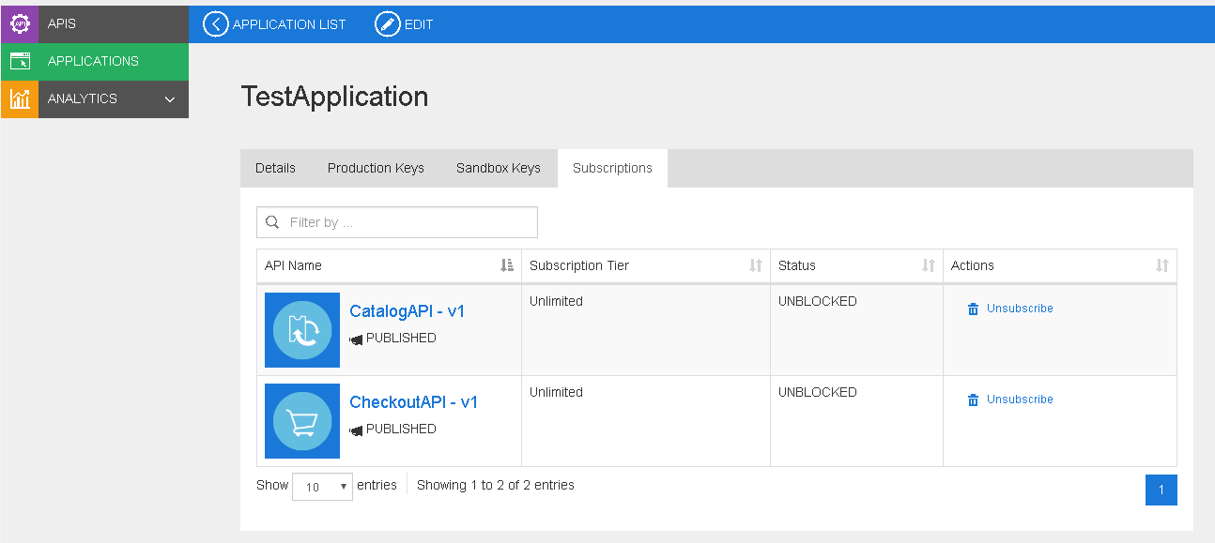

**…**

## Regenerating Access Tokens

A non-expiring Sandbox application token has already been generated for your DefaultApplication. This single token is used to authenticate the DefaultApplication against all of the APIs it is subscribed to, so there is no need to regenerate the token when subscribing to additional APIs.

However, if you want to you can re-generate the token for your DefaultApplication by clicking on “Applications” in the sidebar, choosing the DefaultApplication, then going to the “Sandbox Keys” tab.

To toggle the visibility of your consumer key, consumer secret, and access token, click “Show Keys” at the top of the page.

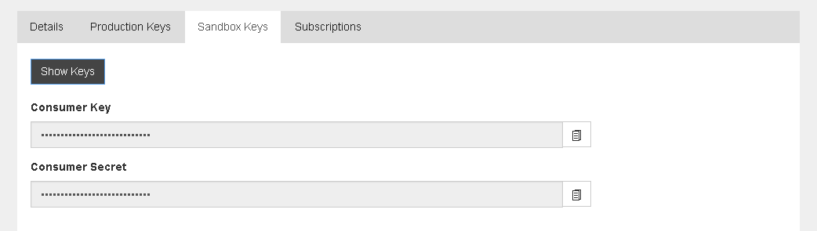

Each application can only have one active token at a time in each environment, so re-generating the token(s) for that application will expire any previous tokens.

To generate a token that doesn’t expire use -1 seconds as the validity period, or choose the number of seconds you want the new token be active for after you generate it.

